Sahil Saini Salaria
Reg No. 180905048
Roll No. 11 C

Question1

#include<stdio.h>
#include<mpi.h>

int main(int argc, char* argv[]){
int rank,size,fact=1,factsum,errclass,resultlen;
char err_buffer[1000];
MPI_Init(&argc,&argv);
MPI_Errhandler_set(MPI_COMM_WORLD,MPI_ERRORS_RETURN);
MPI_Comm_rank(MPI_COMM_WORLD,&rank);
MPI_Comm_size(MPI_COMM_WORLD,&size);
for(int i=1;i<=rank+1;i++){
fact*=i;
}
int ierr=MPI_Scan(&fact,&factsum,1,MPI_INT,MPI_SUM,MPI_COMM_WORLD);
if(ierr!=MPI_SUCCESS){
MPI_Error_class(ierr,&errclass);
if(errclass==MPI_ERR_COUNT){
printf("Invalid rank used in MPI Scan call\n");
MPI_Error_string(ierr,err_buffer,&resultlen);
printf("%s",err_buffer);
MPI_Finalize();
}
}
if(rank==size-1){
fprintf(stdout,"process %d factorial sum %d\n",rank,factsum);
fflush(stdout);
}
MPI_Finalize();
return 0;
}

// mpicc q1.c -lm -o q1 && mpirun -np 4 ./q1

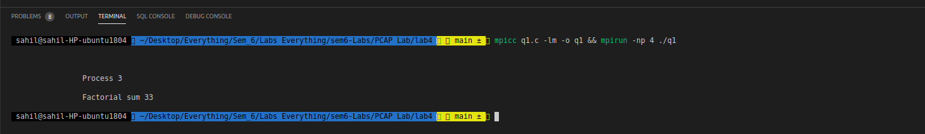

Question 2

#include<stdio.h>
#include<mpi.h>
float func(float x){
return 4/(1+x*x);
}
int main(int argc, char* argv[]){
int rank,size;
MPI_Init(&argc,&argv);
MPI_Errhandler_set(MPI_COMM_WORLD,MPI_ERRORS_RETURN);
MPI_Comm_rank(MPI_COMM_WORLD,&rank);
MPI_Comm_size(MPI_COMM_WORLD,&size);

float interval,mid,height,sum,area;
int errclass;

interval=(1/(float)size);
mid=(rank*interval)+interval/2;
height=func(mid);
area=height*interval;
int ierr=MPI_Reduce(&area,&sum,1,MPI_FLOAT,MPI_SUM,0,MPI_COMM_WORLD);

if(ierr!=MPI_SUCCESS){
MPI_Error_class(ierr,&errclass);
if(errclass==MPI_ERR_COUNT){
printf("Invalid rank used in MPI Scan call\n");

MPI_Finalize();
}
}
if(rank==0){
printf("Process %d pi value is %f\n",rank,sum);
}

MPI_Finalize();
return 0;
}

// mpicc q2.c -lm -o q2 && mpirun -np 4 ./q2

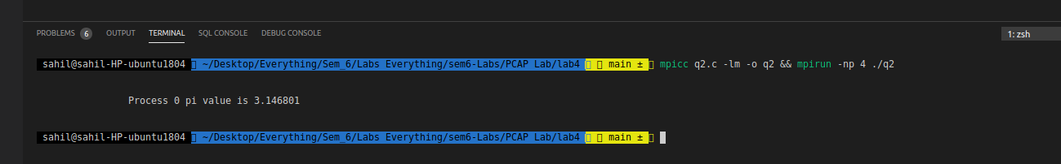

Question 3

#include<stdio.h>
#include<mpi.h>

int main(int argc, char* argv[]){
int arr[3][3],size,rank,occurance=0,element,finsum,b[3],errclass;
MPI_Init(&argc,&argv);
MPI_Errhandler_set(MPI_COMM_WORLD,MPI_ERRORS_RETURN);
MPI_Comm_rank(MPI_COMM_WORLD,&rank);
MPI_Comm_size(MPI_COMM_WORLD,&size);

if(rank==0){
printf("Enter the 9 elements: \n");
for(int i=0;i<3;i++){
for(int j=0;j<3;j++){
scanf("%d",&arr[i][j]);
}
}

printf("Enter the element to search: \n");
scanf("%d",&element);
}
MPI_Bcast(&element,1,MPI_INT,0,MPI_COMM_WORLD);
int ierr=MPI_Scatter(arr,3,MPI_INT,b,3,MPI_INT,0,MPI_COMM_WORLD);

if(ierr!=MPI_SUCCESS){
MPI_Error_class(ierr,&errclass);
if(errclass==MPI_ERR_COUNT){
printf("Invalid rank used in MPI Scan call\n");

MPI_Finalize();
}
}
for(int i=0;i<3;i++){
if(b[i]==element){
occurance++;
}
}
MPI_Scan(&occurance,&finsum,1,MPI_INT,MPI_SUM,MPI_COMM_WORLD);
if(rank==size-1){
printf("Number of occurances of %d is %d\n",element,finsum);
}
MPI_Finalize();
return 0;

}

// mpicc q3.c -lm -o q3 && mpirun -np 4 ./q3

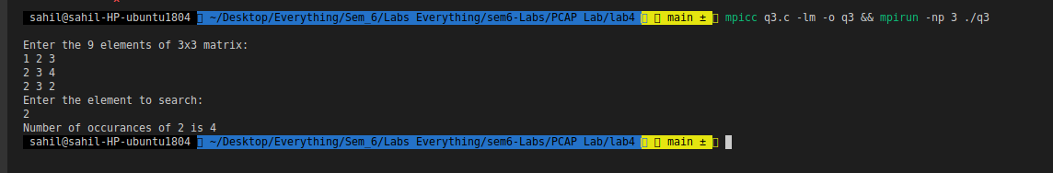
Question 4

#include <mpi.h>
#include <stdio.h>
#include <stdlib.h>
void ErrorHandler(int error_code)
{
if (error_code != MPI_SUCCESS)
{
char error_string[BUFSIZ];
int length_of_error_string, error_class;
MPI_Error_class(error_code, &error_class);
MPI_Error_string(error_code, error_string, &length_of_uerror_string);
printf("Errors:= %d \t %s\n", error_class, error_string);
}
}
int main(int argc, char **argv)
{
int rank, size, error_code;
int arr[4][4], arr2[4], partsum[20], i, j, ele, pos;
MPI_Init(&argc, &argv);
MPI_Errhandler_set(MPI_COMM_WORLD, MPI_ERRORS_RETURN);
error_code = MPI_Comm_rank(MPI_COMM_WORLD, &rank);
ErrorHandler(error_code);
error_code = MPI_Comm_size(MPI_COMM_WORLD, &size);
ErrorHandler(error_code);
if (rank == 0)
{
printf("Enter 4X4 matrix\n");
for (i = 0; i < 4; i++)
{
for (j = 0; j < 4; j++)
{
scanf("%d", &arr[i][j]);
}
}
printf("Ouput Matrix is: \n");
}
MPI_Scatter(arr, 4, MPI_INT, arr2, 4, MPI_INT, 0, MPI_COMM_WORLD);
MPI_Scan(arr2, partsum, 4, MPI_INT, MPI_SUM, MPI_COMM_WORLD);
for (i = 0; i < 4; i++)
{
printf("%d ", partsum[i]);
}
printf(“\n”);

MPI_Finalize();
return 0;
}
// mpicc q4.c -lm -o q4 && mpirun -np 4 ./q4

